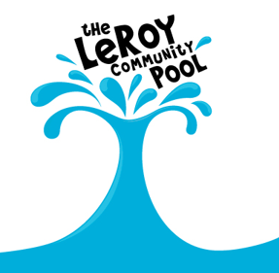
THE LEROY COMMUNITY POOL
PO Box 176
LeRoy, MN 55951
507-324-5742
Aerobics Class Participants
Aerobic Class Schedule
Monday-Wednesday-Friday 8:00-8:45 am
Out of pool and spa by 9:00am
Members paying by the month -- $36.00
Non-members paying by the month -- $48.00
Monday and Friday Members -- $24.00
Pay each time -- $5.00 (please enter $5 on the day as you sign-in)

Tuesday & Thursday 5:00-5:45 pm
Out of pool and spa by 6:00pm
Members paying by the month -- $24.00
Non-members paying by the month -- $32.00
Pay each time -- $5.00 (please enter $5 on the day as you sign-in)

There is a cost break if you pay for classes by the month, because that gives us a basis to determine if there are enough participants to hold the class.
Paying by the month, means you pay for the entire month at the beginning of the month at the reduced rates, regardless if you are able to attend all the classes.
Participants can pay each time they come to the class. That cost is $5.00 per time regardless of being a member or non-member.
If paying by the month, please pay the first week of the month – the costs will be at the top of the sign-in sheet.
Thank you for participating in aerobics class

LeRoy Community Pool Manager
Lindsay Milks

